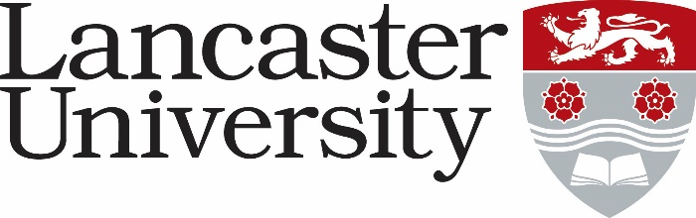

LUMS CAREERS COACH - ACCOUNTANCY : JOB DESCRIPTION

Job Title: LUMS Careers Coach - Accountancy | Present Grade: 7P
Department/College: Lancaster University Management School- Careers (LUMS Careers)
Directly responsible to: Deputy Head of LUMS Careers (Education and Coaching)
Supervisory responsibility for: None
Other contacts

Internal: LUMS Careers; Department of Accounting & Finance; LUMS professional service colleagues; Academic Employability Champions; Student and Education Services; Central Careers Service; partner institutions; Alumni Relations; Students Union; Research and Enterprise Services.
External: Alumni; Regional, National and International Employers; AGCAS; CDI; ISE; other HEIs; Chartered accountancy bodies (ICAEW, CIMA, CAI, CIPFA, ACCA, ICAS).
The Role:

The main purpose of the role is to provide specialist coaching and careers education to students and recent graduates from across the university who aspire to develop careers within the accountancy profession: from management accounting to financial accounting, in the public and private sectors, both nationally and internationally.

This role is a crucial element of the work of LUMS Careers, an innovative and busy team at the heart of the student experience, which continues to make a significant impact on student’s career management skills and employability as measured by destination data, the Graduate Outcomes Survey and the number of students taking internships and placements. The post holder will engage with students as part of the curriculum, through face-to-face and remote 1:1 information, advice, and guidance as required, and through extra-curricular workshops and interventions.

With specific focus on employers and careers in the accountancy profession, this post provides sector-specific advice and information, as well as contributing to building colleagues’ knowledge of the sector.

Major Duties:

- To provide bespoke 1:1 careers coaching, in the form of face-to-face or online appointments, and specialist ongoing support to students and graduates, providing and signposting them to a range of professional careers and employability resources, information, support and guidance.

- To be responsible for planning, communicating, and promoting a specialist accountancy focused employability provision to students, graduates and academic colleagues across the University, to increase the take-up of service provision with the aim of positively influencing destinations data and increasing the numbers of students and graduates engaging with relevant careers service provision.

- To support the development of accredited provision across the School, extra-curricular workshops, events, drop-in clinics and employer engagement activities for students and graduates wishing to develop a career in accountancy. This includes designing and delivering mock assessment centres and case study sessions.
- To work as part of the LUMS Careers Team with departmental academic colleagues to design, deliver and assess innovative undergraduate and postgraduate careers education both in the classroom and through e-learning. Specifically, working on large-scale Part 1 and Part 2 careers education modules within the Department of Accounting & Finance and other departments, as well as delivering on MSc courses where appropriate. To continuously review and improve course materials and contribute to the development of module feedback processes.

- To network and develop partnerships with accountancy bodies, multinational professional service firms, regional employers, boutique practices and public finance accountancy organisations. Highlighting the career progression possibilities available to students both nationally and internationally, and encouraging employer support of student experiential learning opportunities (i.e. work shadowing, insight days, internships, placements) and graduate training contracts.

- To take a leading role in the on-going development of an annual ‘Accounting & Finance Careers Insight Conference’, attended by students across all programmes, key employer delegates and professional accountancy body representatives.

- To support the Department of Accounting & Finance ACA ‘Professional Pathway’ at undergraduate level, coaching students as they gain practical business skills and experience to add to their degree level theory and academic skills.

- To keep up to date with accountancy recruitment practices, knowledge of chartered accountancy and professional qualifications, developments in the wider graduate labour market and relevant employment trends and legislation. To reflect on practice, and develop materials and coaching support accordingly.

- To take part in relevant training, conferences and good practice sharing events, both internally and externally, to ensure the maintenance of an exceptional standard of service delivery.

- To work collaboratively with colleagues in Careers and Employability colleagues across campus to enhance, develop and promote services for students and alumni.

- To work with our internal student recruitment and marketing team, representing LUMS Careers by delivering effective presentations to prospective students outlining our service offering. Delivering during open days, offer holder events, and other recruitment events as may be required, virtually and in person.

- Any other duties related to the post, as may be required.

